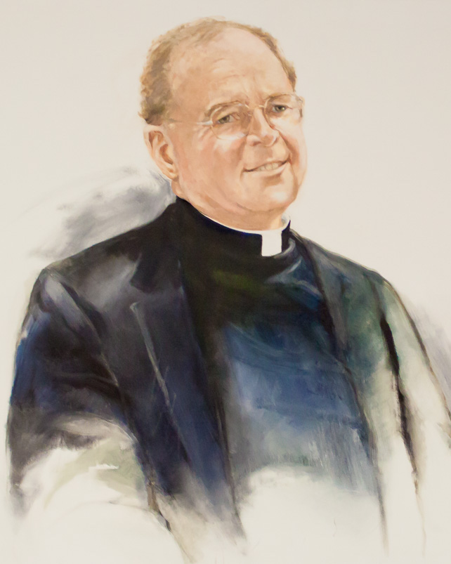

The Good Shepherd School
Annual Golf Tournament
In Memory of
Rev. Harry Tompson, S.J.

March 24, 2017
Audubon Golf Course

$10,000 Give-A-Way Sign-Up Sheet
Only 200 tickets will be sold!!!
Donation: $100 per ticket. Winner need not be present.
Name_____________________________________________ Email ______________________________________________
Address___________________________________________ Phone _____________________________________________
____________________________________________ # of tickets________ Amount $______________
Method of payment (check one) ______Credit card OR _____ Check
Credit Card #_______________________________ Exp. Date_____/_______ Signature____________________________________
Return form and payment to: The Good Shepherd School
Attn: Development
353 Baronne St.
New Orleans, LA 70112
or Email to: development@thegoodshepherdschool.org
***Once payment is received, ticket stub(s) will be returned to purchaser.
For more information call (504) 598-9399.

